Costa Cruise Trip Itinerary
Especially prepared for Penny

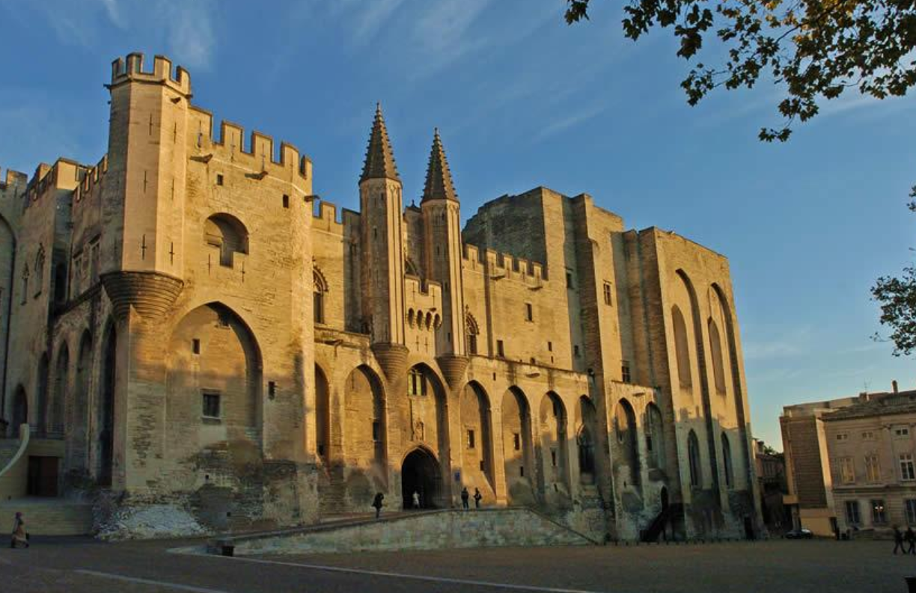

Cruise: Diadema Costa Cruise [24 – 31 Dec. 2017]

DAY 01 24 DEC (SUN) BARCELONA
1500 Private transfer from Vale Apartments (Carrer de València, 191, 08011 Barcelona ) to Costa Cruise Ship. If for any reason, you cannot find your driver, pls. call: +34 717 715 667.

1900 Costa Cruise Diadema departure

DAY 02 25 DEC (MON) AT SEA, CRUISING
No arrangement.

DAY 03 26 DEC (TUE) CAGLIARI
0900 Cruise arrival

0900 You will be picked up from the cruise terminal. If for any reason, you cannot find your guide, pls. call +39 342 5683 303.

Please note that 26 Dec is a holiday in Italy, so the market will be closed. The Palazzo del Consiglio is also closed so only outdoor visit is included.

We set off on foot towards the town centre. The first must-see is the Palazzo del Consiglio Regionale (The Regional Council Building). Sardinia is the homeland of a number of artists, and the outdoor court of this particular building hosts works by Costantino Nivola, a sculptor of international renown. The artwork by this former bricklayer will tell you so much about the cultural heritage of the islanders.

We cross the Marina district, leaving behind St. Eulalia’s church, to reach the second site: the Church of the Holy Sepulchre. We will also visit the Archaeological museum of Cagliari, which houses findings from the pre-Nuragic and Nuragic age to the Byzantine age

We are now in the Castello district, where every single bastion has undergone several attacks and conquests. History is just amazing: strongholds built in the Spanish days and towers erected by Pisa are proof of the efforts made by the invaders to rule the town. The same can be said about the House of Savoy and their legendary taste and passion for architecture: it is not just by chance that they chose this location for their Royal Palace. Castello, Cagliari’s most beautiful district, is packed with original features and history, including St. Mary’s Cathedral and the wealth of scenic terraces overlooking the town. Have some time on your own to explore the town before transferring back to the port.
[5 hrs. vehicle at disposal with driver and local guide]

1800 Cruise departure

DAY 04 27 DEC (WED) PALERMO
You will be at leisure. No arrangement.

DAY 05 28 DEC (THU) CIVITAVECCHIA - VATICAN
0900 Cruise arrival

You will be picked up by your driver for 8 hrs. car at disposal. If for any reason, you cannot find your guide, pls. call +39 342 5683 303.
[Includes 7 – 8 hours of car at disposal with tickets to Roman Forum | no guide]

1900 Cruise departure

DAY 06 29 DEC (FRI) SAVONA - GENOVA
0800 Cruise arrival

0830 You will be picked up by your guide. If for any reason, you cannot find your guide, pls. call +39 342 5683 303.

This private shore trip visits Genoa, well known as the home of Christoper Columbus. You will enjoy a walking tour of the old town, photo stops at panoramic overlooks and a visit to the city's famous aquarium, the largest in Europe.

You begin your city tour with a stop at the panoramic terrace of Castelletto for views over the historical center of Genoa, the port and the Lanterna (lighthouse) which is considered the symbol of the city.

Next, you'll enjoy a walking tour of the old town starting at the House of Columbus near the medieval gate of Porta Soprana. You visit the popular square called Piazza De Ferrari which is the contemporary heart of the town and includes the Carlo Felice Opera House and some beautiful fountains. You also see the Ducale Palace, with its neoclassical facade, which was the seat of the government of the Republic of Genoa.

Then you walk to the Piazza San Matteo, the best-preserved example of a medieval residential quarter. San Matteo was the square of the Doria family area, and still maintains most of its medieval look, including beautiful palaces, porticoes, and traditional black and white striped facades.

Churches seen include Saint Andreas, which is considered a masterpiece of Genovese baroque architecture, the most important period in Genovese art and the Cathedral of San Lorenzo. Built in the 13th century, it is a good example of gothic architecture. Several renovations throughout the ages have also left their mark, and with the variety of art shown one next to the other your visit gives you a virtual course in Italian Art history. You return to the port in Savona later this afternoon.
[6 hrs. vehicle at disposal with driver and local guide]

1700 Cruise departure

DAY 07 30 DEC (SAT) MARSEILLES
0800 Cruise arrival

0800 You will be picked up by your driver. If for any reason you cannot find your driver, pls. call +33 972 301 031.

Once you have left the port of Marseilles you will arrive to Avignon after approx. 1 hour. Six hundred years ago Avignon had a period of prosperity thanks to the Pope who moved here with his court. Seven Popes were here one after another from 1309 to 1403. You will visit the Pope's Palace, which is a palace but also a fortress full of galleries, rooms and chapels that nowadays are empty and give an image of austerity. Nevertheless, the handmade carpets may suggest the vanity of that time. There will be free time for shopping before returning to the ship.
[4 hrs. vehicle at disposal with driver and 2 hrs. local guide]

Rest of the day at your leisure.

1700 Cruise departure

DAY 08 31 DEC (SUN) BARCELONA
0900 Cruise disembarkation
1000 Private transfer from port to Ofellas Hotel Llanca 24 Eixample. If for any reason, you cannot find your driver, pls. call: 34 675 55 4422 or +34 717 715 667.

Inclusions:
- Private transfers (8-seater van), entrance fees, private guide as per the above itinerary.
- Entrance tickets to the Roman Forum

Exclusions:
- Meals
- Gratuities to guide and driver

LIST OF IMPORTANT CONTACTS

Emergency Contact
Spain: +34 717 715 667
Marseille: +33 972 301 031
Italy: +39 342 5683 303

Country Holidays Limited
Tel: +852 2525 9199 / Fax: +852 2525 5199
** 24 hours emergency contact**Hong Kong Mobile: +852 9706 6000

WEATHER
Italy: November to March: Freezing winter. Mountain sports season in the Alps and Apennines.

Cagliari | Palermo | Rome | Genova | Marseille
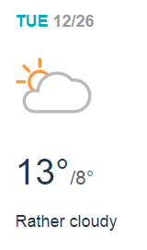 | 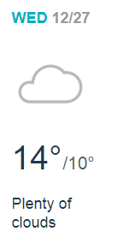 | 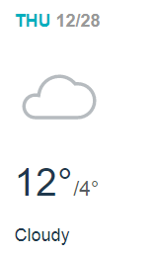 | 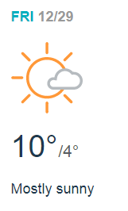 | 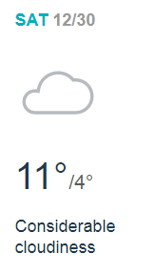

Spain
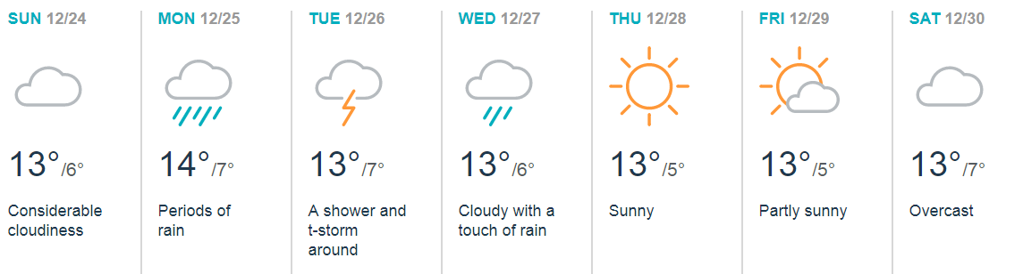
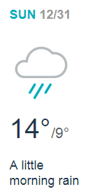

CURRENCY
As Spain, France and Italy are members of the EU, the currency is Euro.
It will be advisable to carry some Euros in cash wherever you go. Most businesses accept credit cards. However, most flea markets and bazaars in the city center take cash only.

It is very easy to exchange currencies in most airports, hotels, banks and money changers. ATMs are also available throughout the country. Hence, you can withdraw money with all major Debit and Credit Cards. ATM services are available 24 hours a day and 7 days a week including public holidays.
Exchange Rates (as of Dec 2017):
1 EUR = 59.13 HKD

1 EUR = 9.16 PHP

TIPPING
It is a normal practice to tip your guides and drivers and our recommendation is as follows. At some up-market restaurants, waiters appreciate a 15% tip, if service charge is not included on the bill.

 | For Group size 5 & above
For guide | EUR 3-5 per traveler per day
For driver | EUR 2-4 per traveler per day

ADDITIONAL NOTES
- Ask permission before taking pictures: Make sure it’s okay to use your camera, especially when taking photographs inside the churches.
- Keep your passport, tickets, and valuables in your in-room safe, or cruise safe deposit box as pickpockets and purse-snatchers are not uncommon, especially in popular tourist spots around Paris and other bigger cities.

- Be wary of tricksters and conmen. They usually work in pairs or groups, so be extra vigilant when approached on the street, even by children or the elderly.

- Do not leave your belongings unattended, especially when seated in restaurants, bars and cafes.

- Beware of road condition: Traffic can be confusing and hectic, be aggressive and alert on the same time. While possible, always look for a painted crosswalk.

TRAVEL INSURANCE

It is highly recommended to take up travel insurance during your visit here. Make sure that the policy you buy covers medical evacuation (which can be very expensive). Insurance documents should be brought along during the trip for emergencies.

